**Exploring the neuroprotective effects of a polyphenol-enriched diet**

Principal Investigator: Richard E. Hartman, Department of Psychology

Co-investigator: Nikita Mistry, Department of Psychology

***Abstract.***

This project will explore the neuroprotective effects of pomegranate juice and/or its main polyphenolic compound (ellagic acid) in a mouse model of mild traumatic brain injury. Polyphenols have antioxidant and anti-inflammatory properties that have been shown to improve behavioral outcomes and neuropathology in mouse models of Alzheimer’s disease, stroke and radiation-induced brain dysfunction. We will assess the behavioral and neuropathological consequences of dietary supplementation with these substances to determine whether they can protect against the mild traumatic brain injury induced by a craniotomy and its associated behavioral deficits. We anticipate that pre-dosing with pomegranate juice will provide significant neuroprotection following mild traumatic brain injury, and therefor reduce any correlated behavioral deficits. Additionally, we anticipate that ellagic acid will be more protective than plain water, but less protective than pomegranate juice, due to the wider spectrum of complementary polyphenolic isoforms in the whole juice. This will be part of a larger project in which a transgenic mouse of Alzheimer’s disease is used to determine the mechanisms behind the neuroprotection.

This is an animal study that will require IACUC approval. Previous IACUC-approved protocols are included in the Appendix.

**Key Personnel:**

**Richard E. Hartman, PhD** – *Principle Investigator*. Responsible for overseeing data analysis and interpretation for this grant, as well as managing the behavioral and histological data collection. I will also review the data and help to prepare manuscripts.

**Nikita Mistry, BS** – *Student Co-investigator*. Responsible for data collection as part of her PhD dissertation project.

monkbookpro750:Users:rico:Desktop:budget.pdf

**A. Specific aims**

This study will explore the potential neuroprotective effects of a polyphenol-enriched diet. Specifically, the study will investigate whether dietary supplementation with pomegranate juice (PJ) and/or its main polyphenol, ellagic acid (EA) can improve neuronal viability and ameliorate behavioral deficits in mice with a mild brain injury.

**Aim 1. Determine whether PJ and/or EA can reduce neuronal loss after mild brain injury.**

Preliminary evidence from our lab in cooperation with Dr. Andre Obenaus’ neuroimaging facilities suggests that a simple craniotomy (5 mm burr hole) can induce a small lesion (approximately 1-1.5% of total brain volume) in the underlying cortex. Other evidence from our lab suggests that diets enriched by fruits with high polyphenolic content (e.g., pomegranates, grapes) can reduce neuropathology in this model and in transgenic mouse models of Alzheimer’s disease. Finally, other evidence (cite Seeram) suggests that isolated polyphenolic components may not provide as effective protection as the whole fruit, which contains a wide variety of potentially complementary polyphenols in various isoforms.

***Hypothesis: We predict that EA mice will have a smaller lesion than control diet mice, and that PJ mice will have a smaller lesion than EA mice after mild brain injury.***

**Aim 2. Determine whether PJ and/or EA can ameliorate behavioral deficits associated with mild brain injury.**

Evidence from our lab suggests that the mild traumatic brain injury induced by a simple craniotomy can induce subtle, but detectable, behavioral deficits. Other evidence from our lab suggests that diets enriched by fruits with high polyphenolic content (e.g., pomegranates, grapes) can ameliorate behavioral deficits following mild brain injury.

***Hypothesis: We predict that EA mice will perform better than control diet mice, and that PJ mice will perform better than EA mice after mild brain injury.***

Ultimately, this project (part of Nikita Mistry’s PhD dissertation project) will generate pilot data necessary for submission of a larger grant to the National Center for Complementary and Alternative Medicine (NCCAM) using a transgenic mouse model of Alzheimer’s disease. Evidence from our lab and others’ suggests that brain injury can accelerate the appearance of Alzheimer’s neuropathology, and that PJ can reduce Alzheimer’s neuropathology and its associated behavioral deficits. This larger study will assess the effects of mild brain injury on Alzheimer’s-like neuropathology in PJ, EA or control-diet transgenic mice and the biochemical mechanisms behind such effects. The experiments outlined in this proposal will contribute to the wildtype control group for comparison with the transgenic group.**B. Significance**

Traumatic brain injuries (TBI), such as those commonly caused from contact sports and vehicular accidents, can have long-lasting cognitive and motor deficits and increase the risk of developing future neurological disorders such as Alzheimer’s disease. Following injury, increased oxidative stress and other factors may ultimately result in neuronal death. There are few pharmacological interventions for TBI, and these are only implemented after the injury occurs, which may be too late to prevent neurodegeneration. Many studies suggest that diets high in antioxidants and polyphenols attenuate neuronal degradation via antioxidant and other pathways. Adherence to these diets pre and post-injury may reduce recovery time and improve cell neuronal viability. If this study shows that preventative dietary factors can ameliorate these effects, reliance on relatively ineffective post-hoc pharmacological treatments could be significantly reduced. Furthermore, the larger NCCAM grant proposal will generate data on the mechanisms of such effects in reducing TBI and Alzheimer’s-related neuropathology, which will help to generate further dietary and/or pharmacological strategies for preventing neurodegeneration following TBI.

**C. Innovation**

The proposed study takes an innovative approach to studying traumatic brain injury in that we are using behavioral and histological methods to assess the effects of a potentially effective and inexpensive treatment approach (prevention of injury via dietary supplementation). Furthermore, we are assessing the possibly synergistic effects of the multiple polyphenols found in whole fruit versus its isolated main polyphenolic component (ellagic acid). Polyphenols have antioxidant and anti-inflammatory properties that may provide neuroprotection to the injured the brain. Commonly found in a wide range of fruit and spices, adding these compounds to the diet may provide an alternative and/or complementary approach to slowing neurodegeneration caused by diseases and/or brain injury.

Berries (Goyarzu et al., 2004), grapes (Ates et al., 2007), and pomegranates (Loren, Seeram, Schulman & Holtzman, 2005) have been found to attenuate oxidative damage, reduce microglial activation (Zhu, Bickford, Sanberg, Giunta & Tan, 2008), and reduce behavioral deficits (Hartman et al., 2006). Although many studies have analyzed the extensive neuronal damage caused by TBI, few studies have investigated the impact of polyphenol-enriched diets on brain injury. In one such study, pregnant mice that consumed pomegranate juice had pups that were more resistant to the effects of neonatal hypoxic-ischemic injury (Loren et al., 2005).

Previously, our lab has shown that brain injury can accelerate Alzheimer’s-like neuropathology in transgenic mice (Hartman et al 2001) and wildtype rats (Pop, et al, 2012). In another study, we showed that treatment of transgenic mice with a pharmaceutical intervention developed by Eli Lilly (passive immunization using a monoclonal A-beta antibody) could significantly prevent and reverse such neuropathology and its associated behavioral deficits. This antibody has recently proven effective in clinical trials and will soon become commercially available. In that experiment, we used hundreds of thousands of dollars worth of the antibody, which required repeated injections over the life of the animal. In a concurrent experiment using pomegranate juice in the drinking water of these mice, we saw similar, if not slightly improved, results using only $30 worth of pomegranate juice (Hartman et al., 2006; Fig. 1). Further data from an ongoing project our lab indicates that consuming a grape-enriched diet for 8 weeks improved motor performance (Fig. 2) in a transgenic mouse model of Alzheimer’s disease. This same diet reduced craniotomy-induced neurodegeneration in normal wildtype mice (Fig. 3). In another ongoing project in our lab, we are assessing the effects of proton radiation exposure on cognitive, affective, and motor outcomes in normal wildtype mice, as well as the potential protective effects of a pomegranate-enriched diet. These mice were exposed to whole body irradiation at 2 Gy and received pomegranate in their drinking water for 6 weeks. Preliminary data indicates that proton radiation is associated with more learned helplessness and depression-like behavior and the PJ diet ameliorated those effects (Fig. 4). Furthermore, pomegranate consumption improved motor performance in male mice (Fig. 5). Thus, if the aims of this project are achieved, they could provide significant and cost-effective benefits over the current and near-future pharmaceutical interventions for TBI and/or other neurodegenerative conditions.

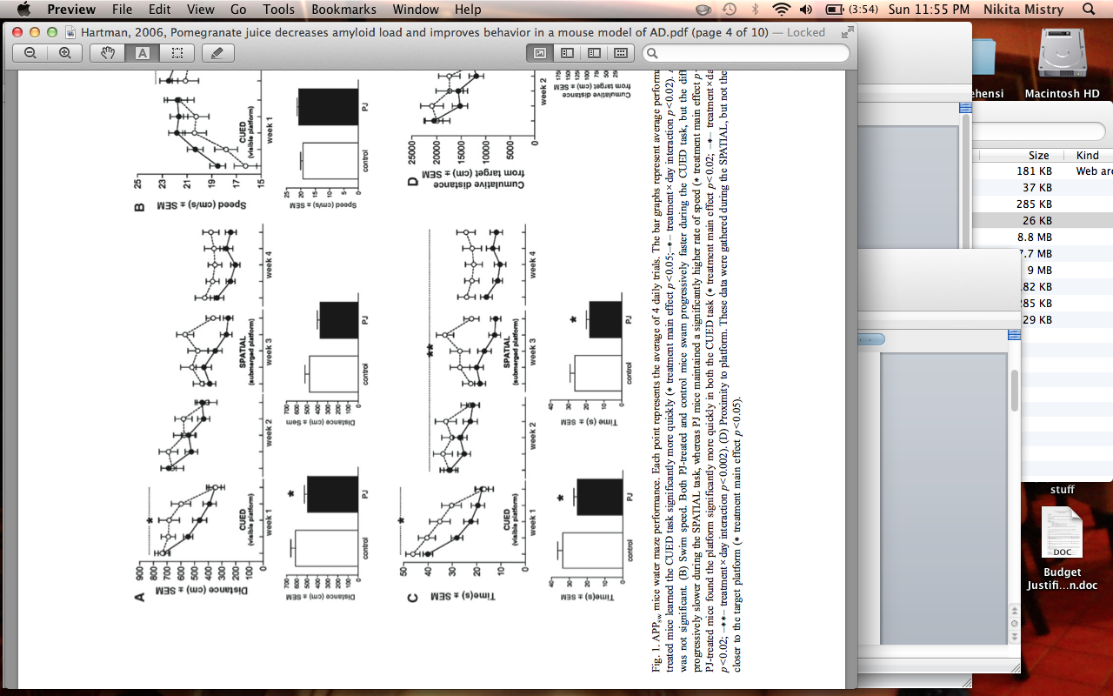**Figure 1.** *PJ-treated mice found the platform of the Morris water maze significantly more quickly in both the CUED and SPATIAL tasks.*

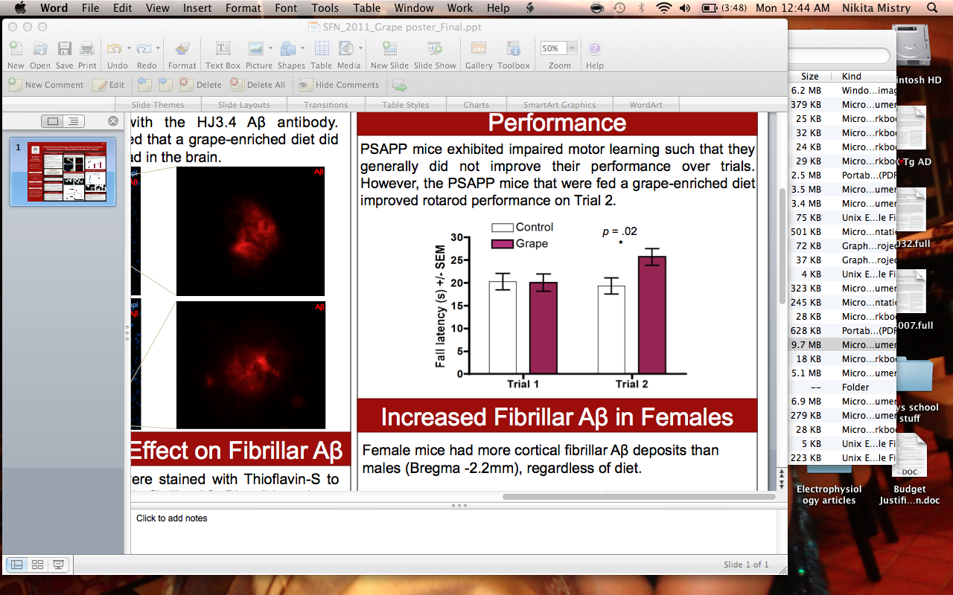**Figure 2.** *Mice fed a grape-enriched diet improved performance on the rotarod.*

**Figure 3.** *Mice fed a grape-enriched diet were less susceptible to craniotomy-induced brain damage.*

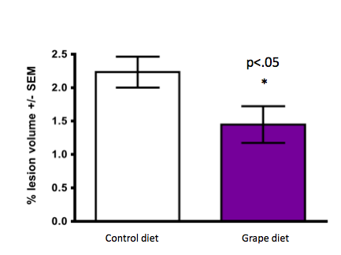

**Figure 4.** *PJ ameliorated radiation-induced learned helplessness / depression-like behaviors.*

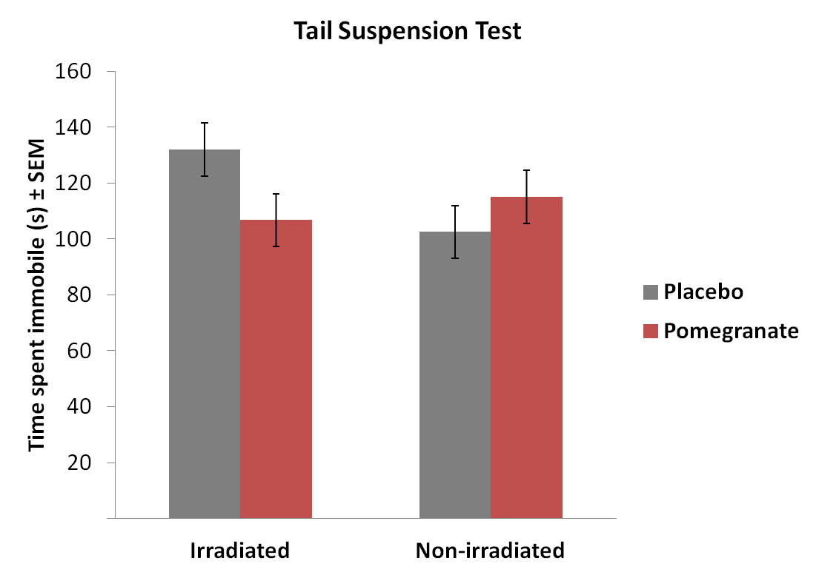

**Figure 5.** *Male mice on the PJ diet exhibited significantly improved motor performance.*

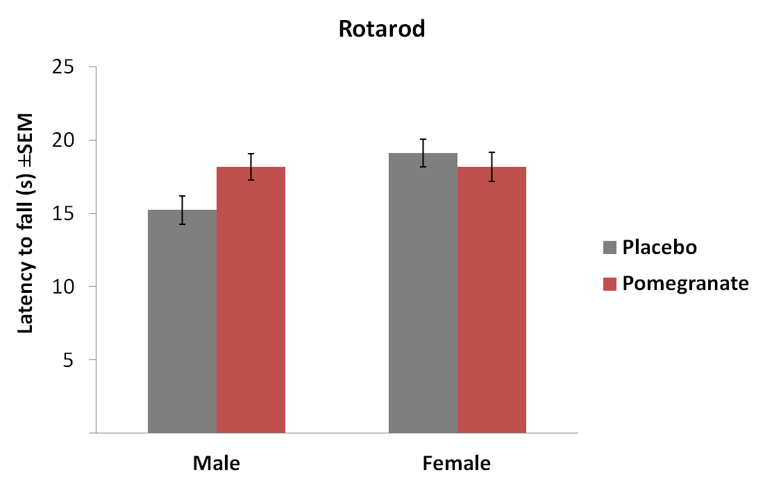

**D. Experimental plan / study design**

Sixty normal male mice (C57BL/6J) at 3 months of age will be used for the study (Jackson Laboratories, ME). Each mouse will undergo a 2-week battery of baseline behavioral tests to assess cognitive and motor abilities. Learning and memory will be assessed with the Morris Water Maze. This is a test of spatial navigation that requires an animal to learn the location of a hidden platform in a pool of water using the visual cues from around the room. The water maze consists of a large metal pool (110 cm diameter) filled with water that is colored opaque with white tempura paint. The pool contains a moveable platform (11 cm diameter) that the animal can step onto to escape the water. Animals will be given a total of 10 trials per day. For each trial, animals will be released with their nose against the wall into the pool at one of the 4 release points and will be allowed to swim to the platform. Trials will last a maximum of 60 seconds and mice will be manually guided to the platform if they did not find the platform in time. An overhead camera will record the swim paths and gather data for the quantification of distance, latency, proximity to target, and swimming speed by a computerized tracking system (Noldus Ethovision). On day 1, animals will be given a cued water maze trial, which is a control task for assessing sensorimotor and/or motivational deficits that may affect performance during the spatial phase. The surface of the escape platform will be visible (5 mm above the surface of the water) with a pole placed on top of the platform to make its location more obvious. The location of the platform will vary from trial to trial. Animals will be released into the pool opposite the location of the platform and will be allowed to remain on the platform for 5 seconds after finding it. On days 2-5, animals will be given a spatial water maze, in which the mice will try to find the platform based on its relationship to the spatial cues around the room, rather than direct visualization. The escape platform will be submerged 1 cm below the surface of the opaque water and the location of the platform will change each day for 3 days. After finding the platform, animals will be allowed to remain on there for an additional 5 seconds. The next day, animals will be given a probe trial in which the platform will be removed from the pool, and the animal will have to search for the platform for 60 seconds. The amount of time the animal spent in the probe quadrant will be measured as well as the total number of times the animal crossed over the former location of the platform. An hour later, the platform will be placed back into the pool at a new location, and the next sets of 10 trials will be administered.

General activity levels and movement patterns will be assessed with an open field activity test, which involves the observation of an animal for 30 minutes in opaque open-topped plastic boxes (49 x 36 cm). Movements of the animal will be recorded with an overhead camera and analyzed by a computerized tracking system. Examples of some of the parameters that will be analyzed include distance moved; percent time spent moving, movement velocity, path meander/tortuosity, and the number of rearings.

Sensorimotor and coordination will be assessed with the accelerating rotarod (Columbus Instruments). This test consists of a rotating horizontal cylinder at a diameter of 3 cm. Mice will be placed onto the cylinder and have to walk continuously forward to avoid falling. Latency to falling off is the dependent variable; with the performance over days of testing is a measure of motor learning. Mice will be tested every other day for 3 days. Three blocks of 2 consecutive trials will be administered per day: 2 stationary trials, 2 trials at 5 RPM, and 2 trials that start at 10 RPM and increased by 2 RPM every 2 seconds.

After baseline testing, the mice will be semi-randomly assigned (performance-matched to assure that all groups are equal at the onset) to 6 groups (injury vs. control, pomegranate vs. ellagic acid vs. none). Mice will receive pomegranate juice (PJ) diluted 1:80, ellagic acid (EA) at .1 mg / ml of water, or plain water in their drinking bottles for 12 weeks. Each animal is predicted to drink an average of 5 ml daily (Hartman et al. 2006), which is roughly equivalent on a mg/kg basis to a human drinking one versus two 8-ounce glasses of PJ per day. Mice on the PJ diet will consume a daily average of 0.5 mg of polyphenols, and mice on the EA diet will consume a daily average of 0.5 mg EA. The daily intake of water (control and PJ) and the weight of animals will be recorded weekly to detect any weight differences between groups.

After 3 weeks, mice will undergo a craniotomy, which produces a mild TBI, or sham surgery, followed by 1 week for recovery. Briefly, animals will be anesthetized and the cortex of the right hemisphere will be exposed with a 5 mm craniotomy 3.0 mm anterior to lambda and 2.7 mm left of the midline of the bregma suture. The heads of the mice will be adjusted to allow the craniotomy to penetrate the thin skull without damaging the dura surrounding the brain.

After recovery, all mice with undergo behavioral tests at 6 weeks of PJ or control treatment to measure acute post-injury differences and again at 12 weeks to measure intermediate effects. After 12 weeks of treatment, the mice will be perfused through the heart with phosphate buffered saline (PBS), and their brains extracted. Brains will be immersed in 4% paraformaldehyde in 0.1 M PBS solution and stored at 4º C. Thereafter, brains will be fixed in a 30% sucrose solution at 4º C for 72 hours, followed by freezing on dry ice. Brains will be cut as free-floating coronal cryostat sections (40 *μ*m) at -20º C from the frontal cortex to the cerebellum. Tissue will be transferred into tubes with cryoprotectant and stored at -20º C. Each tube will have 6-7 tissue sections as a representation of the animal’s entire brain. Tissue from each animal will go through a general 2-day immunohistochemistry protocol to stain neurons (NeuN antibody) and will be cover-slipped with anti-fading medium (Vectashield) containing 4,6-diamino-2-phenylindole (DAPI). The NeuN positive staining in the cortex around the craniotomy site will be analyzed using the Mercator software, and values will be collected using an epifluorescence microscope. The threshold and morphological user-defined parameters will be selected to maximize the visualization of staining and kept consistent for all animals. The program will use a semi-automatic system to count positive staining.

ISPSS 19 will be used to analyze the collected data and an α-level of 0.05 will be used for all statistical significance tests. Immunohistochemistry data for injured brains will be analyzed using a one-way ANOVA with one between-subjects factor (group: control vs. PJ vs. ellagic acid). Any correlations between behavioral and immunohistochemistry variables will be determined using the Pearson product-moment coefficient. Sensorimotor coordination and spatial learning will be analyzed with two-way ANOVAs that include two between-subjects variables (diet: control vs. PJ vs. ellagic acid; injury: craniotomy vs. sham surgery) and one within-subjects variable (test day or trial). To avoid violating the assumptions of sphericity, the reported *p*-values for every repeated measures analysis will reflect the Huynh-Feldt adjustment to the degrees of freedom.

Because the injury must cause enough neurological disturbances to induce observable behavioral deficits, our benchmark for experimental success will include detection of behavioral deficits following craniotomy. If no such deficits are observed, we will adjust test parameters to make them more difficult, which can lead to the emergence of subtle behavioral deficits (Hartman et al., 2005). Also, if we fail to see an amelioration of behavioral deficits following dietary supplementation, we can increase the dose of either pomegranate juice or ellagic acid before sacrifice for brain analysis.

**E. Literature cited**

Ates, O., Cayli, S., Altinoz, E., Gurses, I., Yucel, N., Sener, M., …Yologlu, S. (2007). Neuroprotection by resveratrol against traumatic brain injury in rats. *Molecular and Cellular Biochemistry, 294,* 137-144.

Goyarzu, P., Malin, D.H., Lau, F.C., Taglialatela, G., Moon, W.D., Jennings, R., … Joseph, J.A. (2004). Blueberry supplemented diet: Effects on object recognition memory and nuclear factor-kappa b levels in aged rats. *Nutritional Neuroscience, 7(2),* 75-83.

Han, S., & Chung, S. (2006). Marked hippocampal neuronal damage without motor deficits after mild concussive-like brain injury in Apolipoprotein E-deficient mice. *Annals of New York Academy of Sciences, 903,* 357-365.

Hartman, R. E., Wozniak, D. F., Nardi, A., Olney, J. W., Sartorius, L., & Holtzman, D. M. (2001). Behavioral phenotyping of GFAP-apoE3 and -apoE4 transgenic mice: apoE4 mice show profound working memory impairments in the absence of Alzheimer’s-like neuropathology. *Experimental Neurology*, *170*(2), 326–344.

Hartman, R. E., Lee, J. M., Zipfel, G. J., & Wozniak, D. F. (2005). Characterizing learning deficits and hippocampal neuron loss following transient global cerebral ischemia in rats. *Brain Research*, *1043*(1-2), 48–56.

Hartman, R. E., Izumi, Y., Bales, K. R., Paul, S., Wozniak, D. F., & Holtzman, D. M. (2005). Treatment with an amyloid-beta antibody ameliorates plaque load, learning deficits, and hippocampal long-term potentiation in a mouse model of Alzheimer’s disease. *Journal of Neuroscience*, *25*(26), 6213–6220.

Hartman, R.E., Shah, A., Fagan, A.M., Schwetye, K.E., Parsadanian, M., Schulman, R.N., … Holtzman, D.M. (2006). Pomegranate juice decreases amyloid load and improves behavior in a mouse model of Alzheimer’s disease. *Neurobiology of Disease, 24,* 506-515.

Loren, D.J., Seeram, N.P., Schulman, R.N., & Holtzman, D.M. (2005). Maternal dietary supplementation with pomegranate juice is neuroprotective in an animal model of neonatal hypoxic-ischemic brain injury. *Pediatric Research, 57(6),* 858-864.

Pop, V., Sorensen, D. W., Kamper, J. E., Ajao, D. O., Murphy, P. M., Head, E., & Hartman, R. E. (2012). Early brain injury alters the blood – brain barrier phenotype in parallel with b-amyloid and cognitive changes in adulthood. *Journal of Cerebral Blood Flow & Metabolism*, (May), 1–10

Seeram, N., Adams, L. S., Henning, S., Niu, Y., Zhang, Y., Nair, M. G., & Heber, D. (2005). In vitro antiproliferative, apoptotic and antioxidant activities of punicalagin, ellagic acid and a total pomegranate tannin extract are enhanced in combination with other polyphenols as found in pomegranate juice. *Journal of Nutritional Biochemistry*, *16*(6), 360–367.

Uryu, K., Laurer, H., McIntosh, T., Praticò, Martinez, D., Leight, S., … Trojanowski, J.Q. (2002). Repetitive mild brain trauma accelerates Aβ deposition, lipid peroxidation, and cognitive impairment in a transgenic mouse model of Alzheimer amyloidosis. *The Journal of Neuroscience, 22(2),* 446-454.

Zhu, Y., Bickford, P.C., Sanberg, P., Giunta, B., & Tan, J. (2008). Blueberry opposes *β*-amyloid peptide-induced microglial activation via inhibition of p44/42 mitogen-activation protein kinase. *Rejuvenation Research, 11(5),* 891-901.